Using the RFID Reader

Today we have an m3pi robot with an RFID reader attached to it.
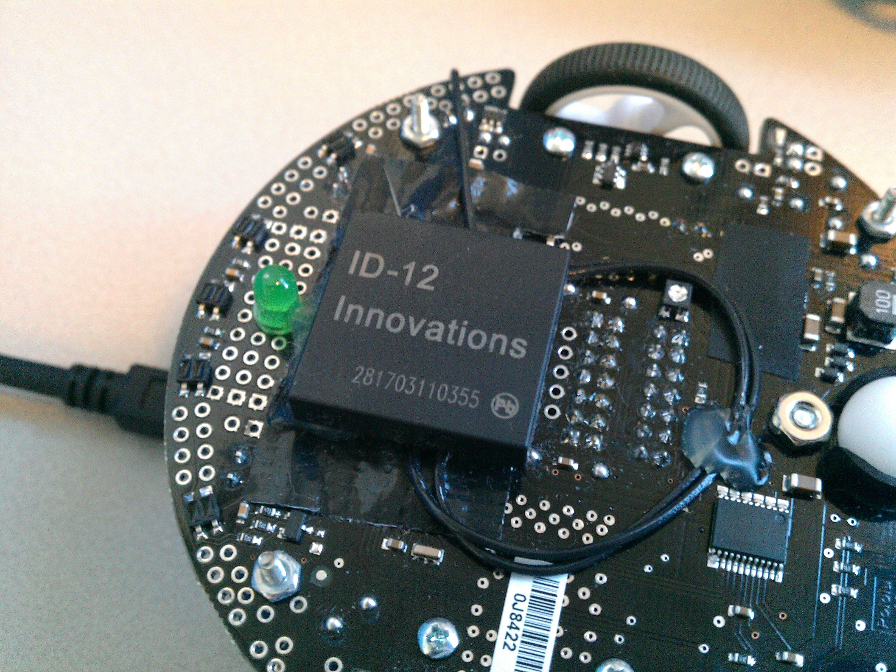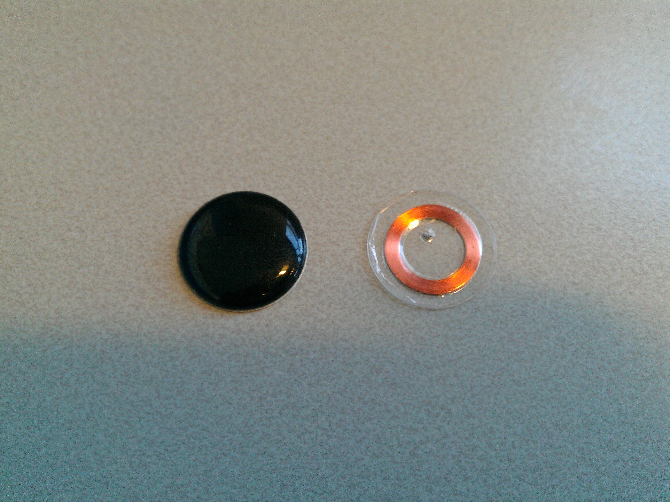

RFID tags are small microchips that hold an ID. Some uses of RFID tags:
- It is common for department stores to hide these tags in items they are selling to catch people who are stealing.
- An RFID tag is hidden inside a car key. When the driver starts the car, it only starts if the ID is correct.

A very simple program that uses the RFID to read a tag is shown below:

// m3pi RFID Reader Example

#include "mbed.h"
#include "m3pi.h" // m3pi robot controls
#include "ID12RFID.h" // RFID reader library

m3pi m3pi;

// This is needed to access the RFID Reader...
ID12RFID rfid(p14);

int main() {

m3pi.locate(0,0);
m3pi.printf("RFIDRead");

while (1) {

// Check if the reader is reading an ID?
if(rfid.readable()) {

// Get the ID from the reader...
int id = rfid.read();

// Print it on the LCD...
m3pi.locate(0,1);
m3pi.printf("%d", id);
}
}
}

When you write the above program, you will need to import the following libraries into it:
- http://mbed.org/users/chris/libraries/m3pi/lr20a4
- http://mbed.org/users/simon/libraries/ID12RFIDIRQ/lphqc7

The important parts related to the RFID reader are highlighted above.

Challenge

We will put an RFID tag under the start/finish line of the race track. Your line follower program can be modified to read this tag, so that it knows how many times it has passed this line. Can you update the line follower program to stop after it has done three laps of the race track?

Hints

Define a variable that is used for counting as follows.

int counter = 0;

To add one to this counter, use the following code:

counter++;

The following code will check if the value of the counter is 10 or more.

if (counter >= 10) {
// do something
}

To stop the motors on the m3pi, you can use the stop function:

m3pi.stop();

